**Project Design Phase-II**

**Technology Stack (Architecture & Stack)**

|  |  |
| --- | --- |
| Date | 22 October 2022 |
| Team ID | PNT2022TMID37911 |
| Project Name | Project - AI-Based localisation and classification of Skin disease with erythema. |
| Maximum Marks | 4 Marks |

**Technical Architecture:**

The Deliverable shall include the architectural diagram as below and the information as per the table1 & table 2

**Example: Order processing during pandemics for offline mode**

**Reference:** [**https://developer.ibm.com/patterns/ai-powered-backend-system-for-order-processing-during-pandemics/**](https://developer.ibm.com/patterns/ai-powered-backend-system-for-order-processing-during-pandemics/)

Guidelines:

1. Get the image from the User.
2. Use Feature Extraction method for better Classification.
3. Use several best Algorithm techniques like CNN, ANN, KNN, SVM, etc... to get accurate results.
4. By testing and get compared with trained results it predicts and detect the diagram pattern.
5. Finally, the Machine learning will predict with more efficiency.

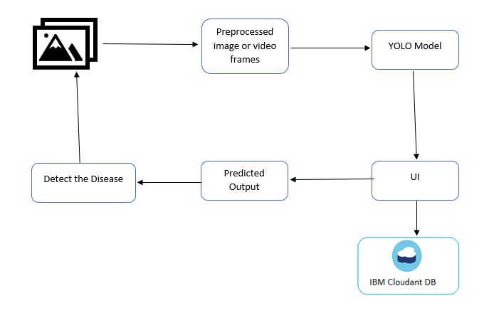

**Table-1: Components & Technologies:**

|  |  |  |  |
| --- | --- | --- | --- |
| **S. No** | **Component** | **Description** | **Technology** |
|  | User Interface | How user interacts with application e.g.  Web UI, Mobile App, Chatbot etc. | HTML, CSS, JavaScript / Angular Js / React Js etc. |
|  | Application Logic-1 | Logic for a process in the application | Java / Python |
|  | Application Logic-2 | Logic for a process in the application | IBM Watson STT service |
|  | Application Logic-3 | Logic for a process in the application | IBM Watson Assistant |
|  | Database | Data Type, Configurations etc. | MySQL, NoSQL, etc. |
|  | Cloud Database | Database Service on Cloud | IBM DB2, IBM Cloudant etc. |
|  | File Storage | File storage requirements | IBM Block Storage or Other Storage Service or Local Filesystem |
|  | External API-1 | Purpose of External API used in the application | IBM Weather API, etc. |
|  | External API-2 | Purpose of External API used in the application | Aadhar API, etc. |
|  | Machine Learning Model | Purpose of Machine Learning Model | Object Recognition Model, etc. |
|  | Infrastructure (Server / Cloud) | Application Deployment on Local System / Cloud  Local Server Configuration:  Cloud Server Configuration : | Local, Cloud Foundry, Kubernetes, etc. |

**Table-2: Application Characteristics:**

| **S.No** | **Characteristics** | **Description** | **Technology** |
| --- | --- | --- | --- |
|  | Open-Source Frameworks | List the open-source frameworks used | Technology of Opensource framework |
|  | Security Implementations | List all the security / access controls implemented, use of firewalls etc. | e.g. SHA-256, Encryptions, IAM Controls, OWASP etc. |
|  | Scalable Architecture | Justify the scalability of architecture (3 – tier, Micro-services) | Technology used |
|  | Availability | Justify the availability of application (e.g. use of load balancers, distributed servers etc.) | Technology used |
|  | Performance | Design consideration for the performance of the application (number of requests per sec, use of Cache, use of CDN’s) etc. | Technology used |

**References:**

[1] Arifin, S., Kibria, G., Firoze, A., Amini, A., & Yan, H. (2012) “Dermatological Disease Diagnosis Using Color-Skin Images.” Xian: *International Conference on Machine Learning and Cybernetics*.

[2] Yasir, R., Rahman, A., & Ahmed, N. (2014) “Dermatological Disease Detection using Image Processing and Artificial Neural Network. “Dhaka*: International Conference on Electrical and Computer Engineering*.

[3] Santy, A., & Joseph, R. (2015) “Segmentation Methods for Computer Aided Melanoma Detection.” *Global Conference on Communication Technologies.*

[4] Zeljkovic, V., Druzgalski, C., Bojic-Minic, S., Tameze, C., & Mayorga, P. (2015) “Supplemental Melanoma Diagnosis for Darker Skin Complexion Gradients.” *Pan American Health Care Exchanges*

[5] Suganya R. (2016) “An Automated Computer Aided Diagnosis of Skin Lesions Detection and Classification for Dermoscopy Images.” *International Conference on Recent Trends in Information Technology*.

[6] Alam, N., Munia, T., Tavakolian, K., Vasefi, V., MacKinnon, N., & Fazel-Rezai, R. (2016) “Automatic Detection and Severity Measurement of Eczema Using Image Processing.” *IEEE*.